Getting Started for Parents
Both students and parents can use the many tools available through Family Connection. The Counselor is working with students to set up their student accounts in the program.
To access the College Planning tools in Family Connection, log in and click the Colleges tab.
College Search
You can start your college search by using the College Search or SuperMatch™ college search tools.
To search for colleges using College Search:
- Click the Colleges tab in Family Connection.
- Click College Search in the College Research section.
- Complete the search by making selections in each section (type, location, students, admission, athletics, majors, costs, special programs). Each selection filters the results of your search.
- Click the Next button at the end of each section to move through the search tool.
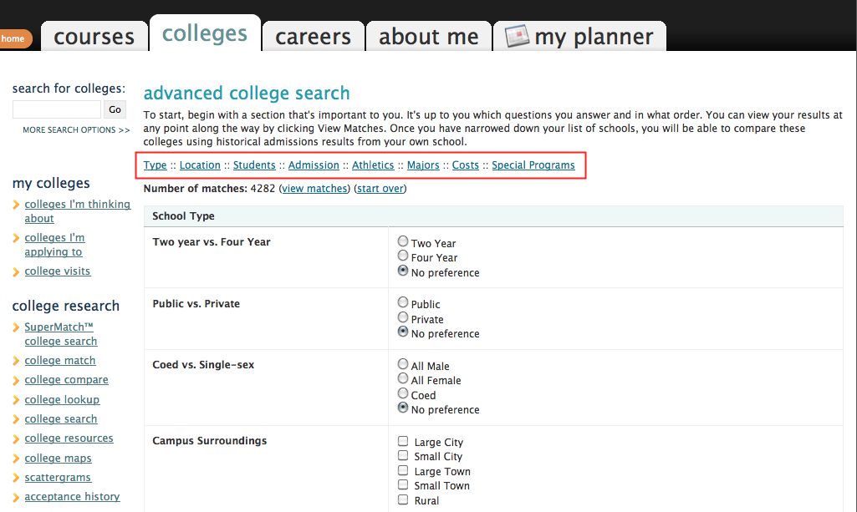
To view results:
- At any time you can view the results by clicking the Show Matches button at the bottom of the page.
- A list of colleges that match your selections will appear.
- Click the college name link to view the college profile where a lot of valuable information can be found.

To save searches:
- You can save the search by clicking Save Search next to the number of matches.

To search for colleges using SuperMatch™:
- Click the Colleges tab in Family Connection.
- Click SuperMatch College Search in the College Research section.
- Use the Find & Pin School By Name or Find Your Best Fit filters to search for your best college matches, pin your favorites, and compare schools side by side.

College Application Materials
Your can request college application material using Family Connection, including transcripts and teacher recommendations.
To request a transcript for a college:
- Click the Colleges tab in Family Connection.
- Click the Colleges I’m Applying To link.
- Complete the Common App Account Matching process.
- Click the Request Transcripts link.
- Select your decision type from the Type drop-down menu.
- Click the Lookup link next to the College field.
- Search for the college.
- Click the college name.
- Repeat steps 6-9 for as many colleges as needed.
- Click the Request Transcripts button.
- A confirmation page appears and the college is added to your Colleges I’m Applying to List.
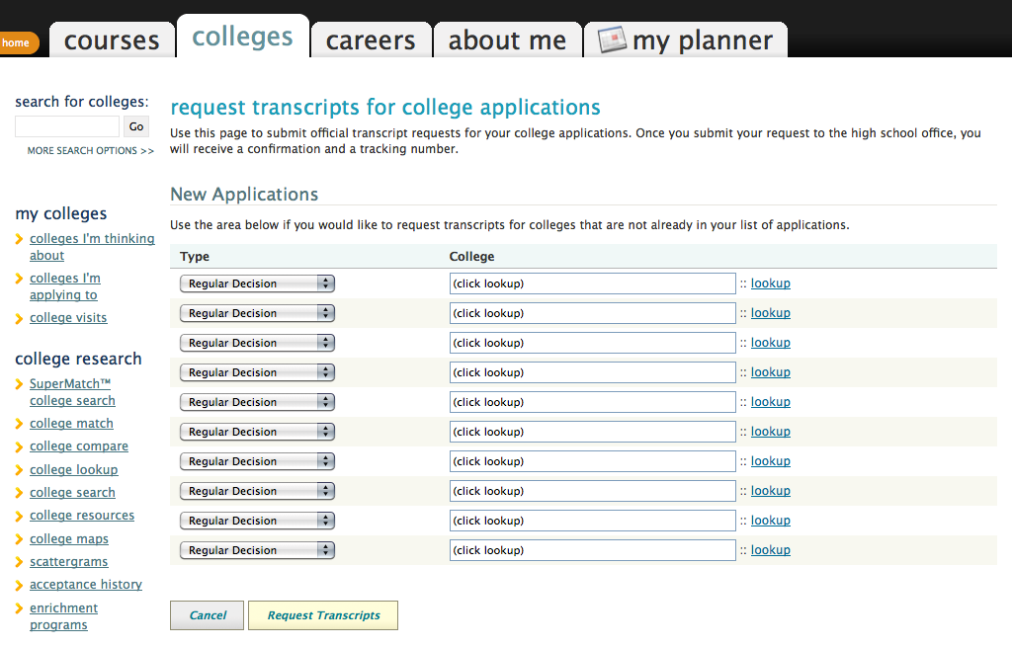
Scholarships and Financial Aid
Finding information about scholarships and financial aid can be an important part of the college application process.
The Scholarships and Money section provides tools to help in your search.
To search for local scholarships that may be a match for you:
- Click the Colleges tab in Family Connection.
- Click the Scholarship List link in the Scholarships & Money section.
- A list of scholarships appears. This list is maintained by Huntsville City Schools Counselors and includes scholarships that are sent to us by local and state organizations.
- Click on the specific scholarship name to view details for the scholarship.

To search a national database for scholarships with requirements that may be a match for you:
- Click the Colleges tab in Family Connection.
- Click the National Scholarship Search link.
- Enter your profile information for the Sallie Mae national scholarship search tool to find scholarships that may be a match.

